1. **Perform transformation using homography matrix.**

**Aim:**

To perform transformation using homography matrix.

**Code:**

import cv2

import numpy as np

im_src = cv2.imread("C:\\Users\\prith\\Documents\\CV\\cvimage.jpg")

pts_src = np.array([[141, 131], [480, 159], [493, 630], [64, 601]])

im_dst = cv2.imread("C:\\Users\\prith\\Documents\\CV\\cvimage.jpg")

pts_dst = np.array([[318, 256], [534, 372], [316, 670], [73, 473]])

h, status = cv2.findHomography(pts_src, pts_dst)

if im_dst is not None:

im_out = cv2.warpPerspective(im_src, h, (im_dst.shape[1], im_dst.shape[0]))

cv2.imshow('Source Image', im_src)

cv2.imshow('Destination Image', im_dst)

cv2.imshow('Warped Image', im_out)

cv2.waitKey(0)

cv2.destroyAllWindows()

else:

print("Error: Could not load destination image.")

**Input:**

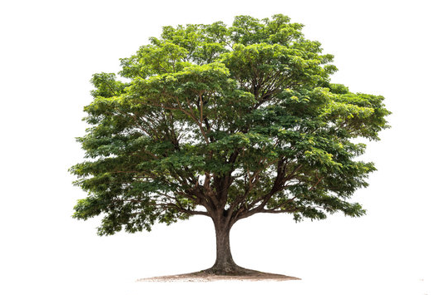

**Output:**

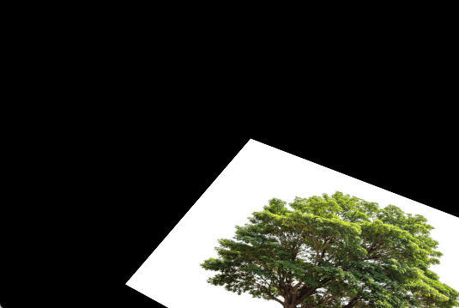

**Result:**

The python code to perform transformation using homography matrix has been executed successfully.